There are n cities connected by some number of flights. You are given an array flights where flights[i] = [fromi, toi, pricei] indicates that there is a flight from city fromi to city toi with cost pricei.

You are also given three integers src, dst, and k, return ***the cheapest price****from*src*to*dst*with at most*k*stops.*If there is no such route, return-1.

**Example 1:**

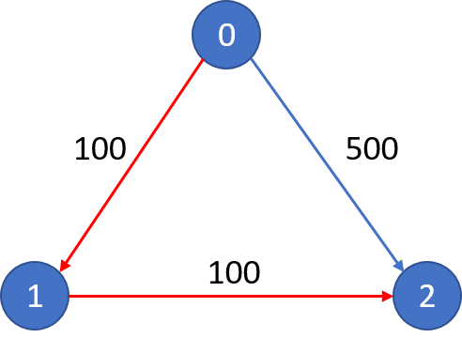

**Input:** n = 3, flights = [[0,1,100],[1,2,100],[0,2,500]], src = 0, dst = 2, k = 1

**Output:** 200

**Explanation:** The graph is shown.

The cheapest price from city 0 to city 2 with at most 1 stop costs 200, as marked red in the picture.

**Example 2:**



**Input:** n = 3, flights = [[0,1,100],[1,2,100],[0,2,500]], src = 0, dst = 2, k = 0

**Output:** 500

**Explanation:** The graph is shown.

The cheapest price from city 0 to city 2 with at most 0 stop costs 500, as marked blue in the picture.

**Constraints:**

* 1 <= n <= 100
* 0 <= flights.length <= (n * (n - 1) / 2)
* flights[i].length == 3
* 0 <= fromi, toi < n
* fromi != toi
* 1 <= pricei <= 104
* There will not be any multiple flights between two cities.
* 0 <= src, dst, k < n
* src != dst